

***SZABIST (KHA)***

***JANUARY, 2021***

***CSCL1108 LAB: INTRODUCTION TO COMPUTER SCIENCE***

***(SADIA AZIZ)***

***PROJECT: HANGMAN***

***BY,***

***ALI ZAFAR QURESHI (2012374)***

***MUHAMMAD OWAIS KHALID (2012396)***

***JAVERIA SHEIKH (2012386)***

|  |  |  |
| --- | --- | --- |
| *SN.* | *TABLE OF CONTENT* | *PAGENO.* |
| *01.* | *Acknowledgment Page* | *2.* |
| *02* | *Summary* | *3* |
| *03.* | *Introduction* | *3* |
| *04.* | *Background* | *3* |
| *05.* | *Working of Project* | *6* |
| *06.* | *Scope of Project* | *29* |
| *07.* | *Conclusion* | *29* |

***ACKNOWLEDGMENT***

Thank you to all of those members who helped in creating the project and to all the teachers who cleared the concepts of the participants of the project. Their hard work is showing the true shining colors. The participants of this project are

* Ali Zafar Qureshi (2012374)
* Muhammad Owais Khalid (2012396)
* Javeria Sheikh (2012386)

**SUMMARY**

In our implementation of Hangman, the computer will take on the role of the "chooser" and the human player will be the "guesser." The computer will secretly choose a word from a list and show the player how many letters are in the word by displaying a sequence of blanks. Then, the computer will begin asking for guesses. If the player guesses a letter that is in the secret word, all blanks representing an instance of that letter should be replaced by the letter. If the guessed letter is not in the word at all, the player should lose a chance and a new part of the Hangman figure should appear. If the player guesses a letter he or she has already guessed, he or she should not lose a chance, even if that letter is not in the word. If the player guesses all letters in the word, he or she wins. If the Hangman figure is completed, the player loses. In either case, the secret word should be revealed after the game is over. The game can be played again and again and again.

**MAIN BODY**

**Introduction:**

Hangman is a popular word guessing game where the player attempts to build a missing word by guessing one letter at a time. After a certain number of incorrect guesses, the game ends and the player loses. The game also ends if the player correctly identifies all the letters of the missing word.

**Background (with algorithm and flowchart):**

**Algorithm:-**

Step 1: Start.

Step 2: Ask user if he/she wants to play single player or pvp.

Step 3: For pvp the user itself enters the secret word to be guessed by P1 player and plays the game and vice versa for P2 player.

Step 4: For single player the user must guess the secret word (animal) given by the computer for the game to be won.

Step 5: select a secret word by default.

Step 6: Ask a player to guess the word (animal)

Step 7: If the player guessed the secret word (animal) in limited guesses, he won.

Step 8: If the player was unable to guess the secret word (animal) in limited guesses he loses.

Step 9: After the limited guesses are over ask the player if he wants to play again or not.

Step 10: End.

**Flowchart:-**

Start

Ask user if he/she wants to choose option 1 or2

Option 1(single player)

Option 2(PvP player)

Ask User for a secret word for P1 and vice versa.

For single player, the user must guess the secret word provided by computer.

Select a secret word by default.

The answer is correct then

You won, want to play again or exit?

You lose, want to play again or exit?

End

**Working of Project:**

Coding:-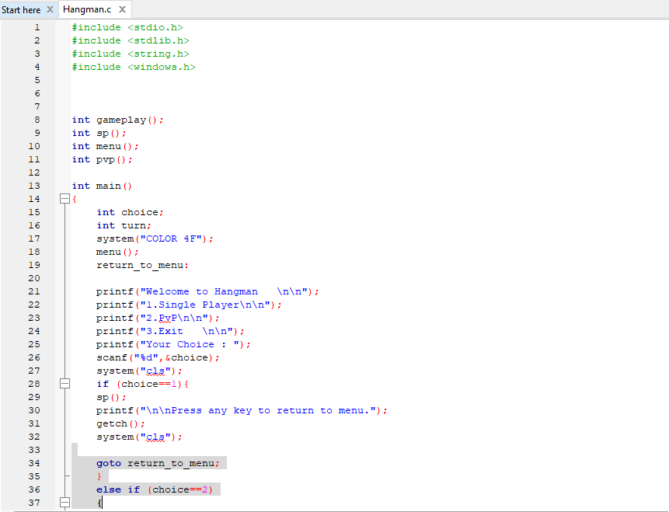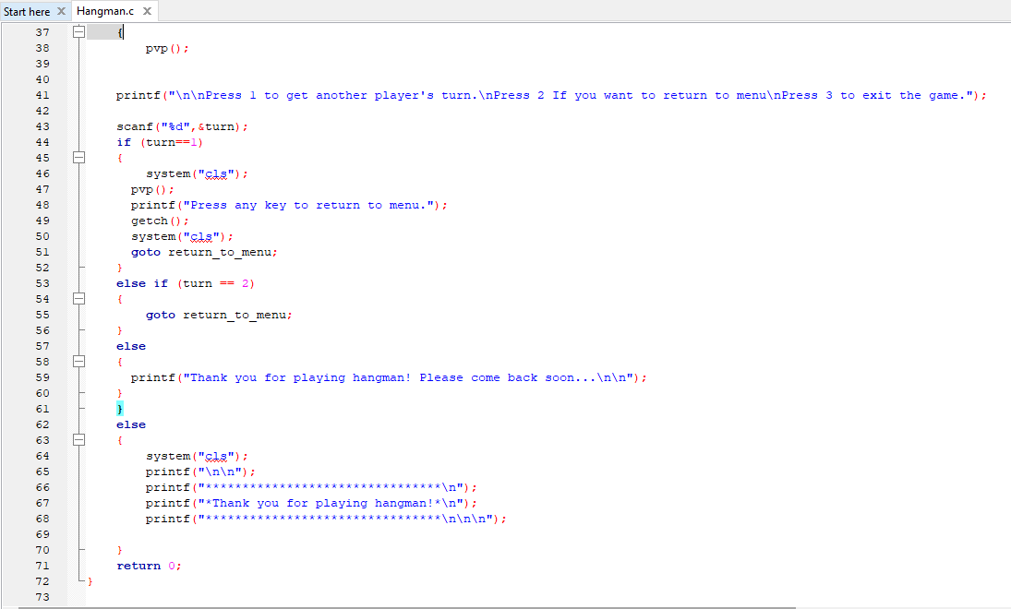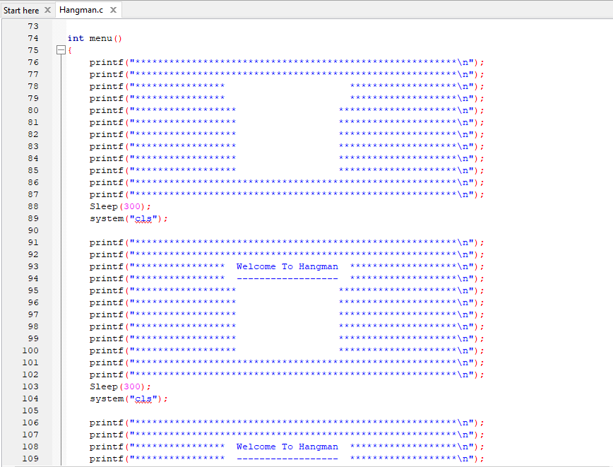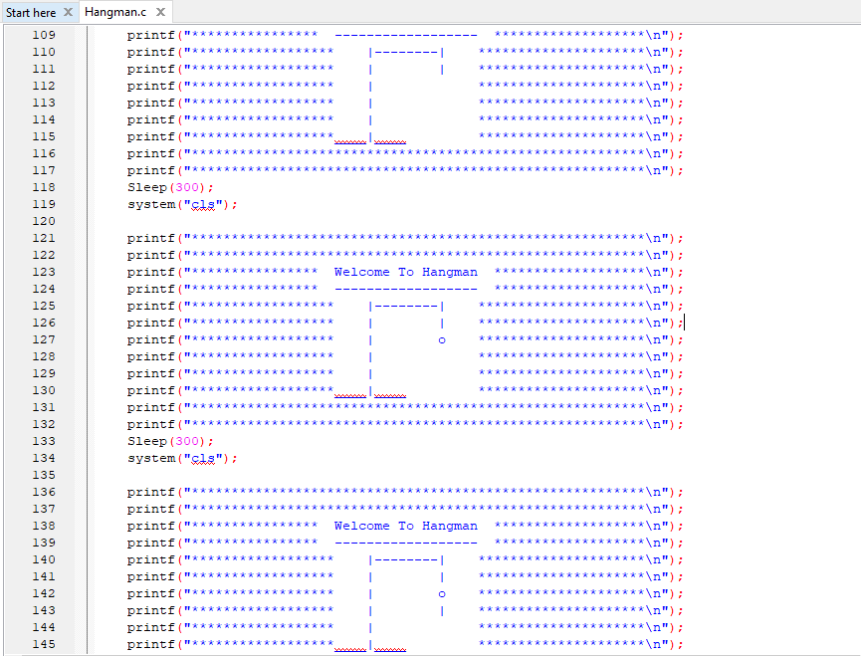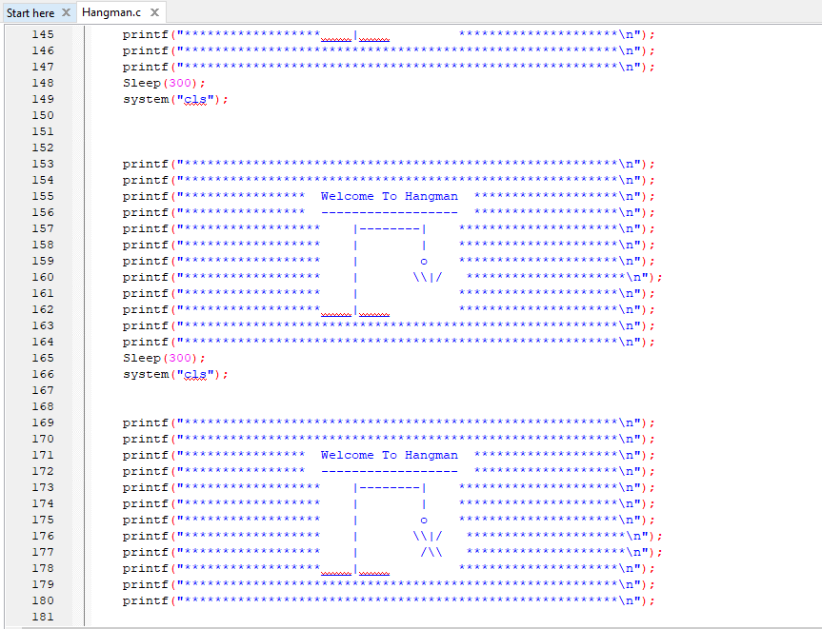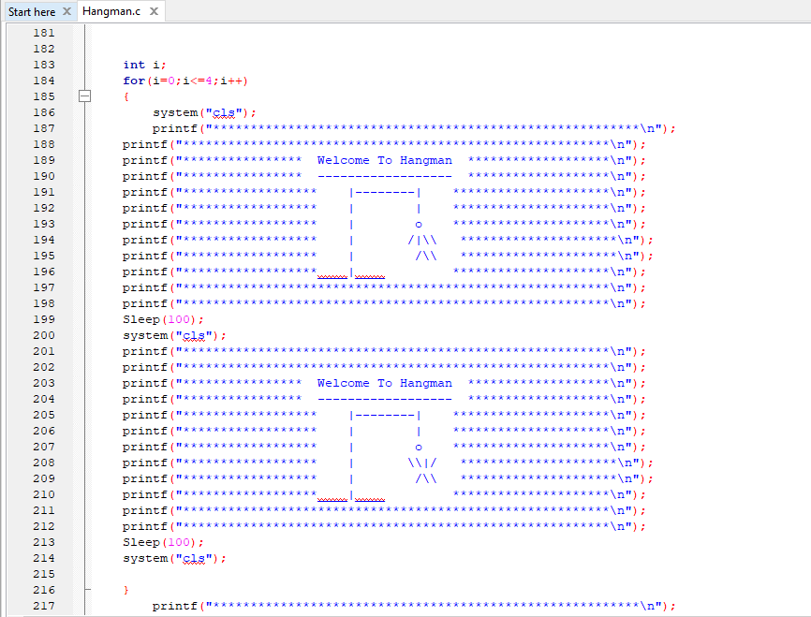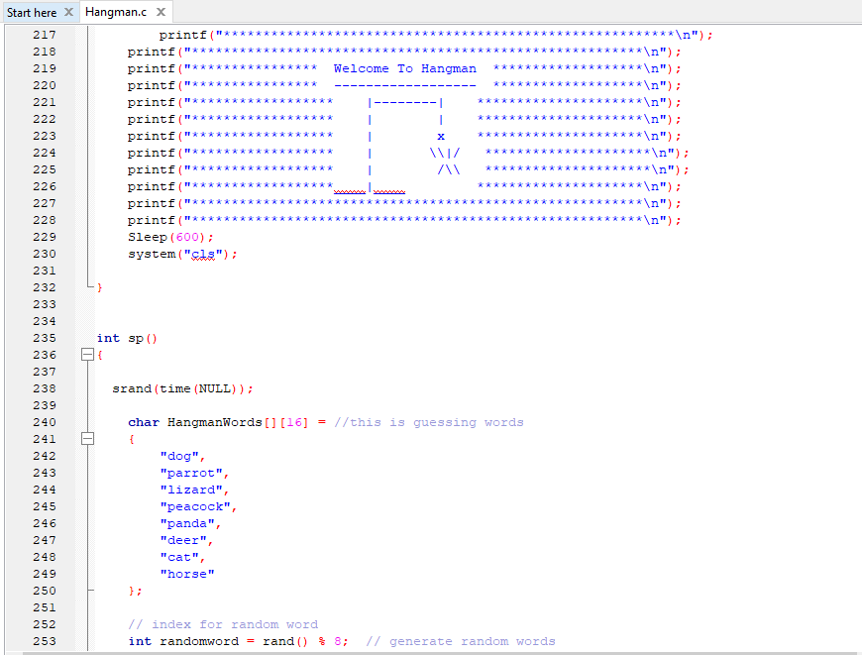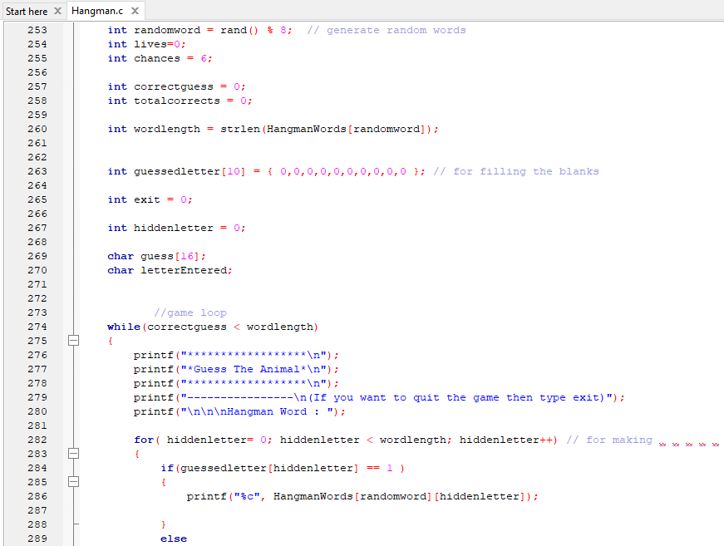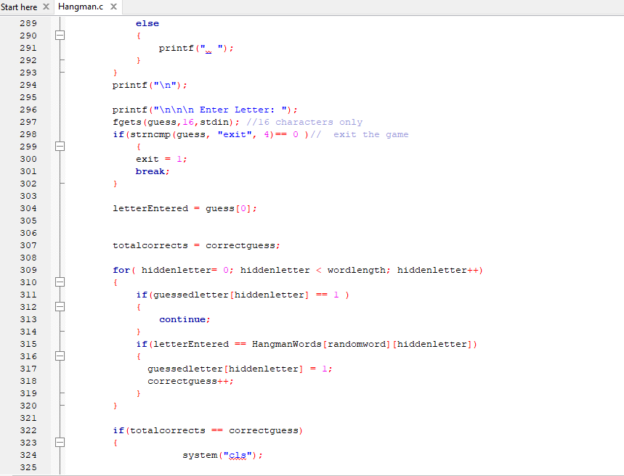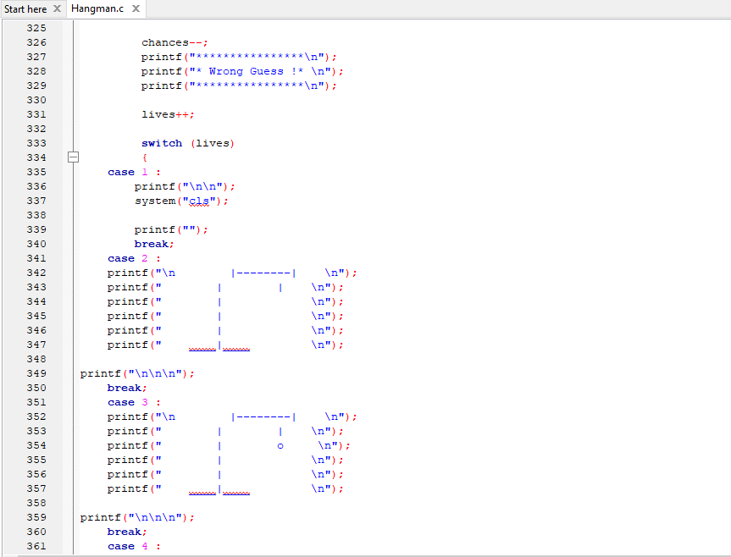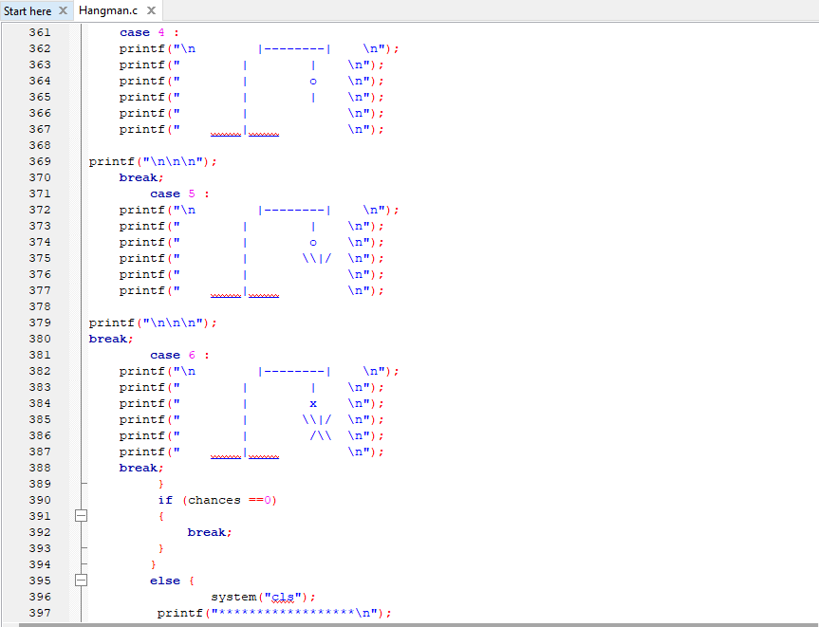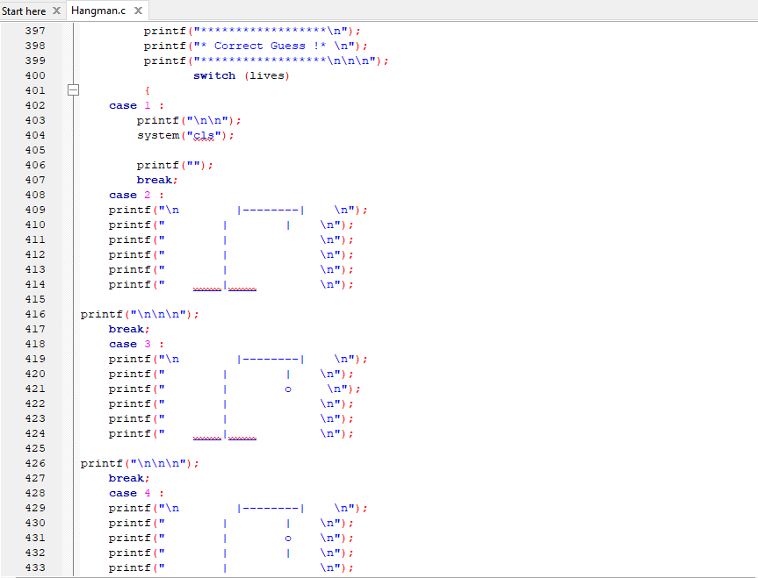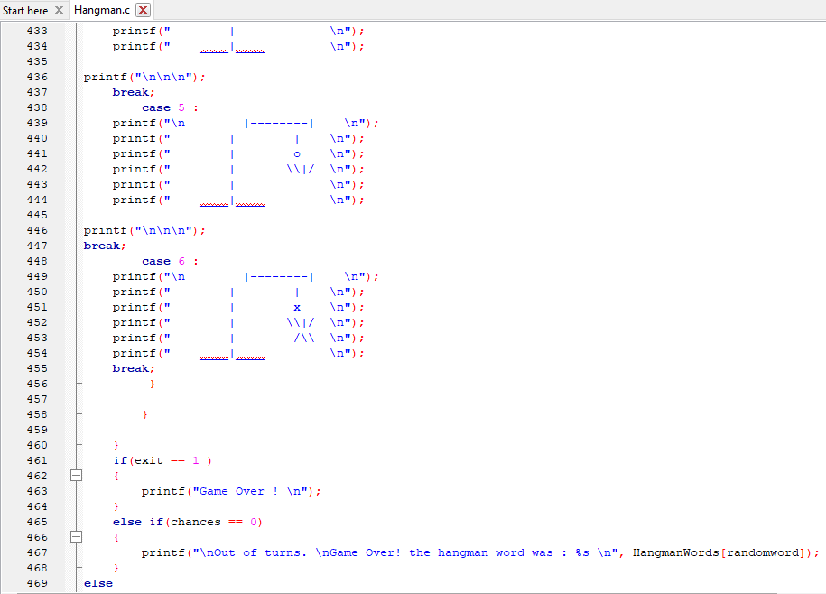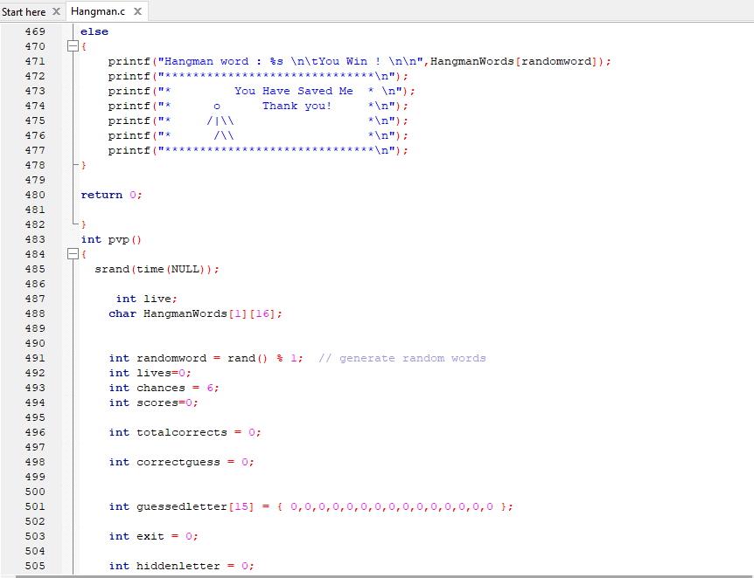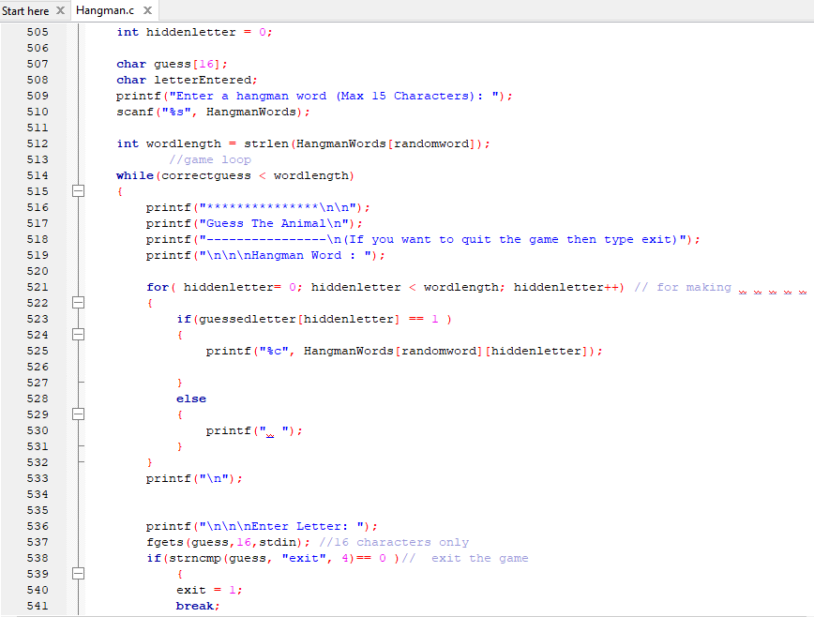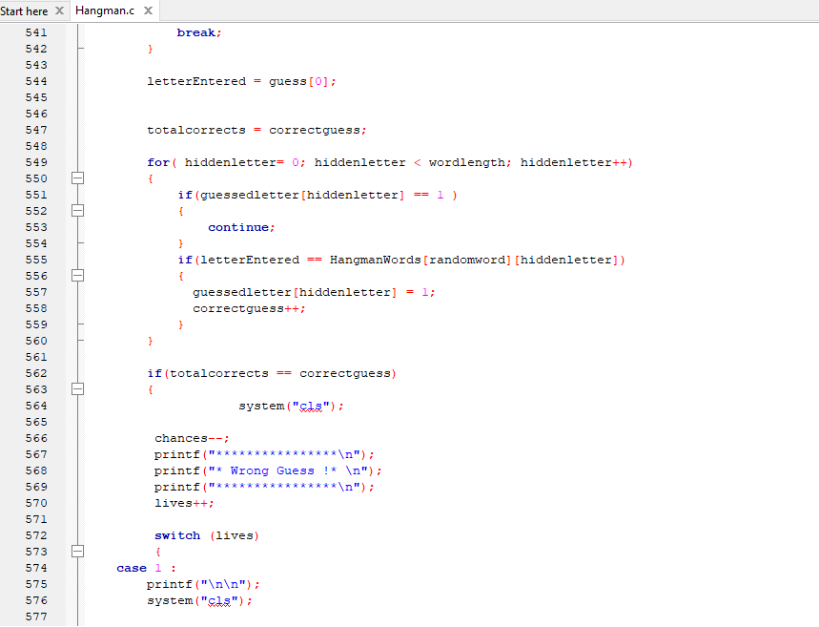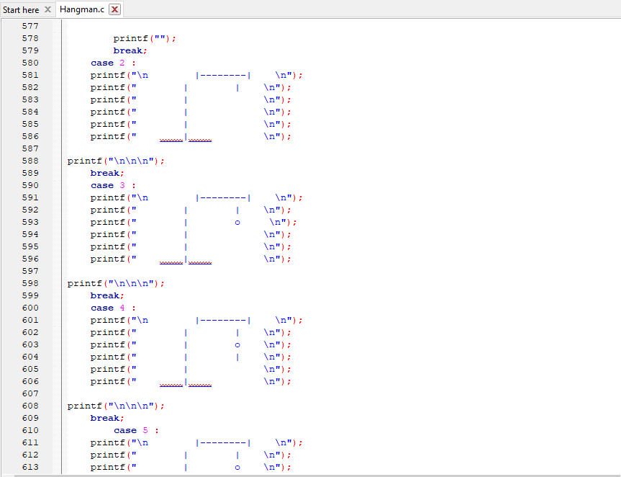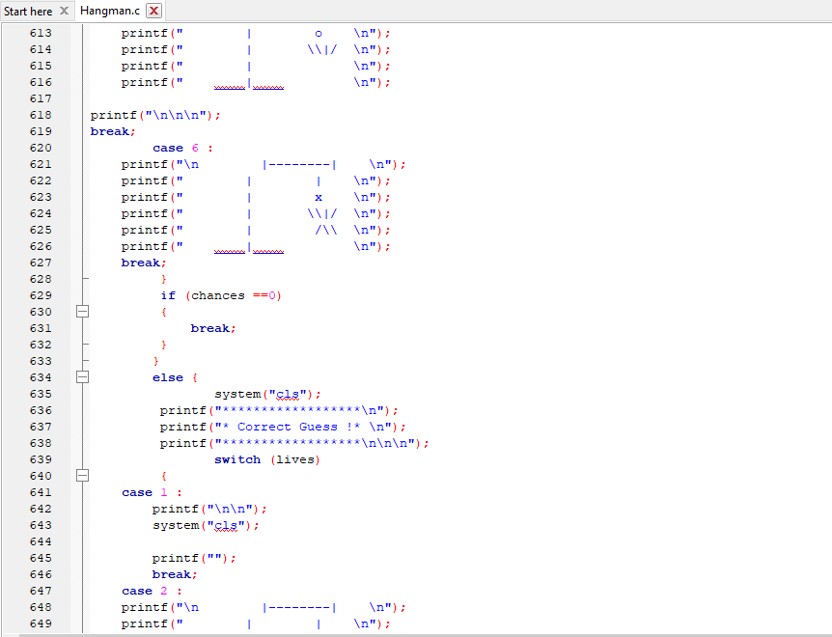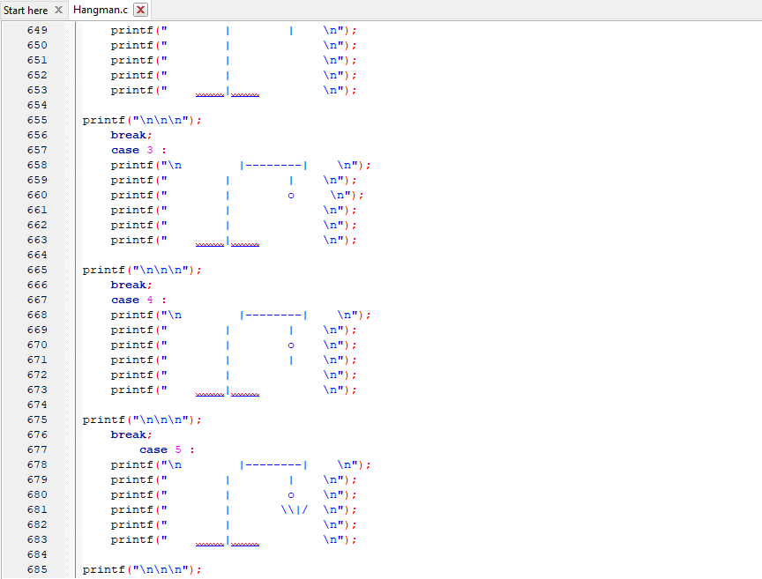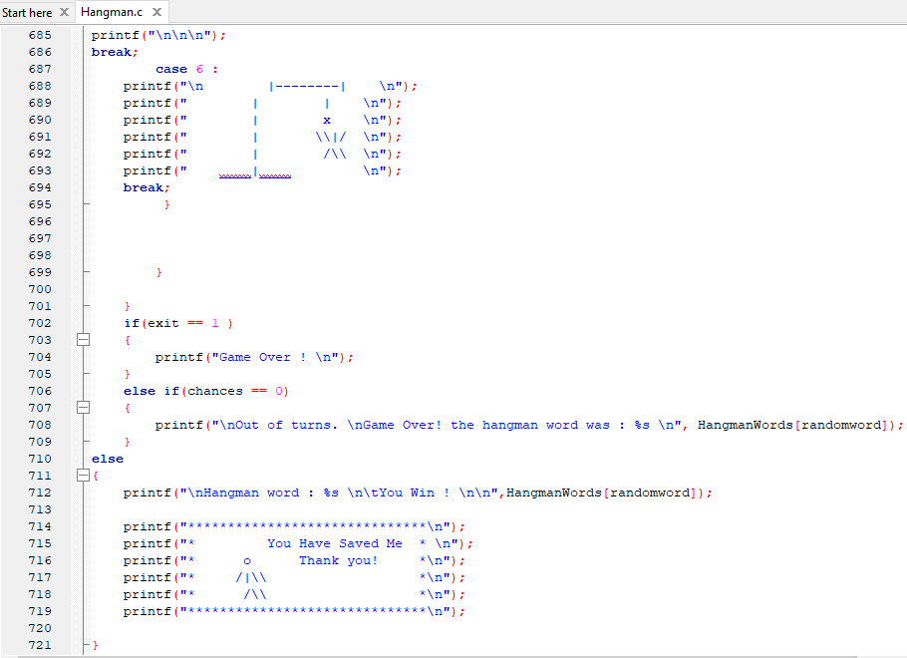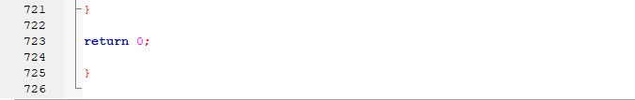

Result:-

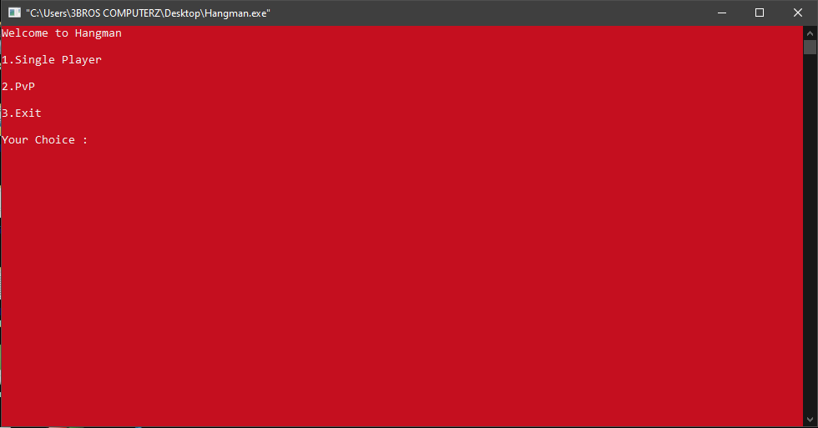

If selecting option 1: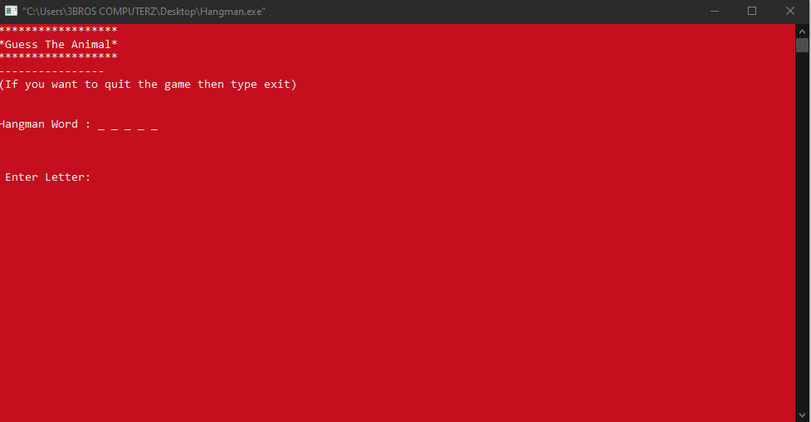

If answer is correct:

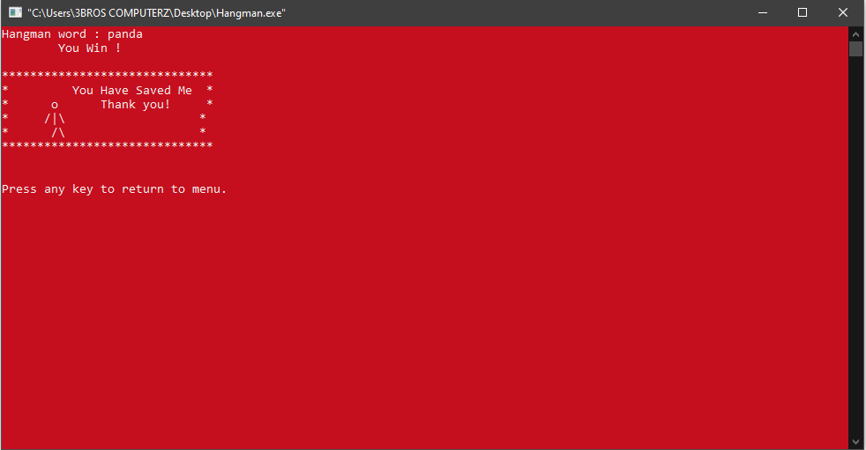

If the answer is incorrect:

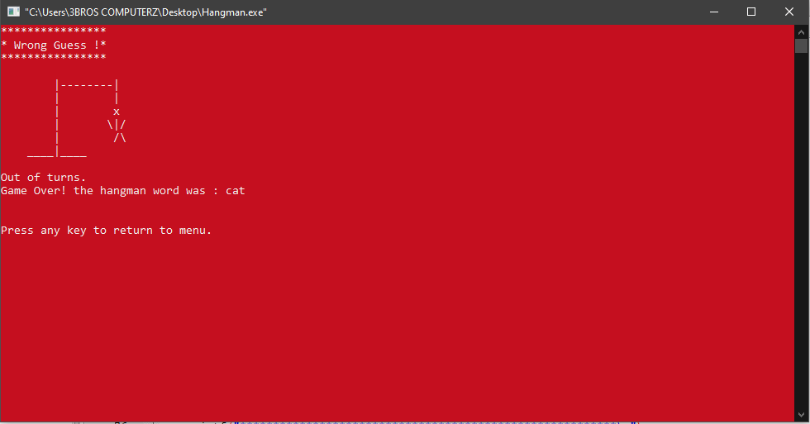

If selecting option 2:

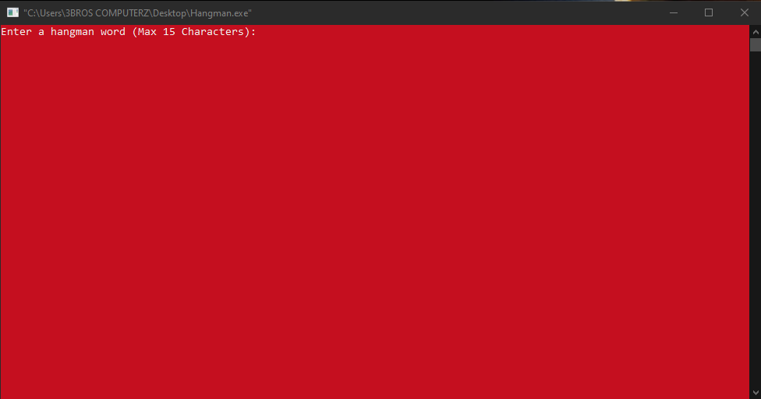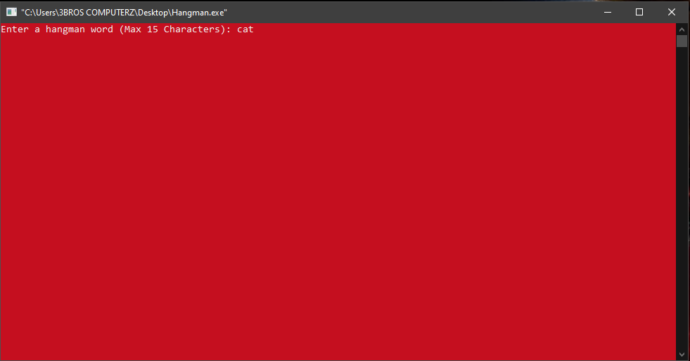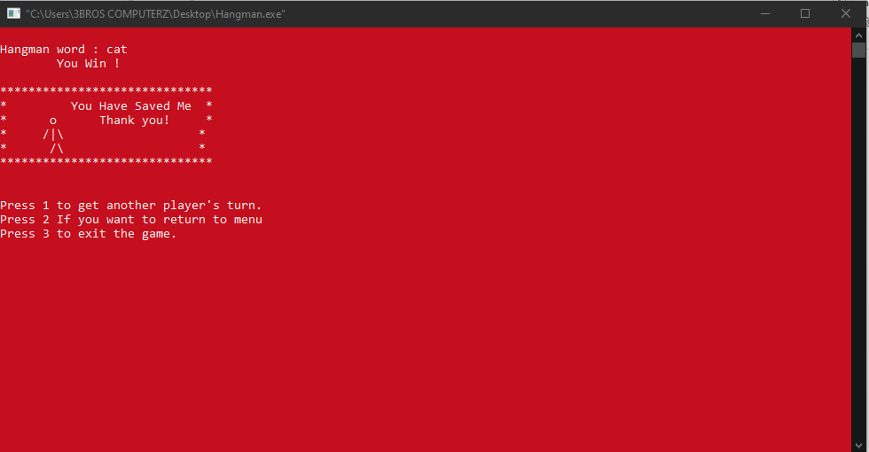

If the answer is incorrect:



**Scope of the Project:**

The scope of this project is to polish our skills, entertainment purpose and to accomplish good grades.

**Conclusion:**

Everything has two sides (Negative/Positive). After all one thing we create, this game for fun and our aim is to polish skills. We request everyone to take the game positively.

**References:-**

The logic of hangman was not that easy. It was little bit complicated. So we have collected some information from a senior and from the following links:-

https://codereview.stackexchange.com/questions/217820/beginning-c-hangman

https://www.usna.edu/Users/cs/roche/courses/f20ic210/notes/06/files.php?f=hangman.c

https://gist.github.com/saroj22322/aa2f0849f33736395544c2d341ab3722